DATABASE SYSTEM ENGINEERING AND DISTRIBUTED BACKEND DEVELOPMENT

Week – 2 Practical
Experiment: BookFlow Library Management System
Name: Ravi Abhishiktha
Roll No.: 2520030185
Section: 5
AIM
To create a Library Management Database (BookFlow) using MySQL, implement constraints, perform JOIN and GROUP BY operations, demonstrate ACID Transactions, and improve search performance using Indexing.
Step 1: Create the Database
SQL Query
CREATE DATABASE bookflow_db;
USE bookflow_db;
OUTPUT:

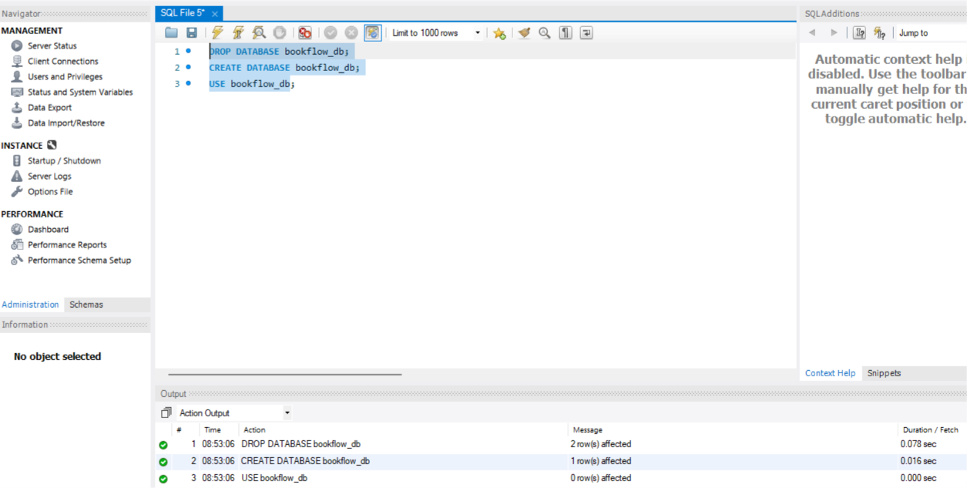

Step 2: Create the Books Table
SQL Query
CREATE TABLE Books (
book_id INT PRIMARY KEY,
title VARCHAR(100) NOT NULL,
isbn VARCHAR(20) UNIQUE,
published_year INT CHECK (published_year < 2027)
);
OUTPUT:

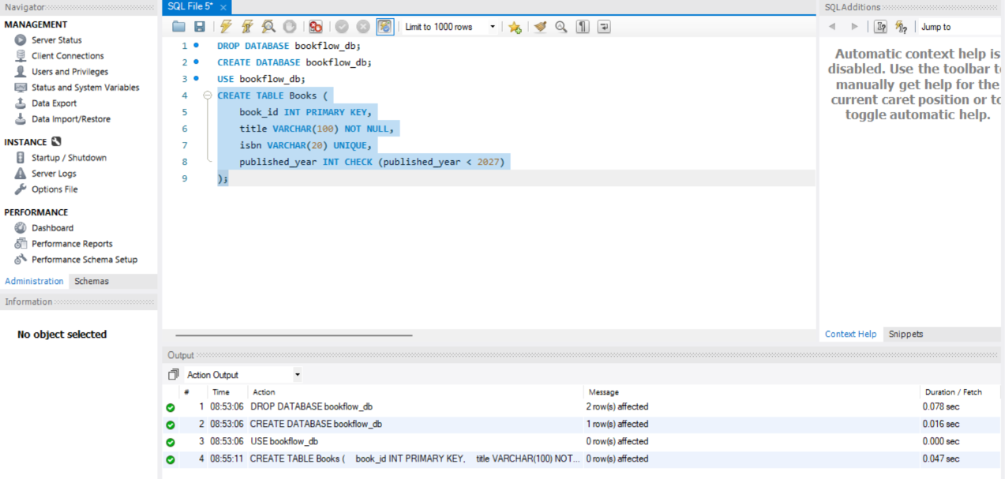
Step 3: Insert Records into Books Table
SQL Query
INSERT INTO Books (book_id,title,isbn,published_year)
VALUES
(1,'The Great Gatsby','9780743273565',1925),
(2,'To Kill a Mockingbird','9780061120084',1960),
(3,'1984','9780451524935',1949);

SELECT * FROM Books;
OUTPUT:
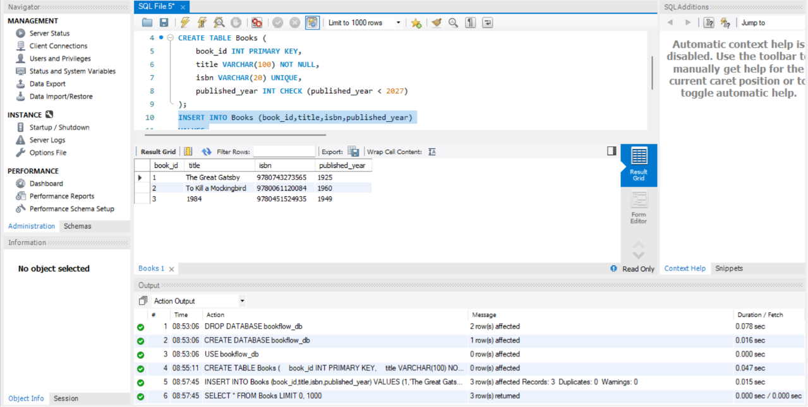

Step 4: Create Members Table
SQL Query
CREATE TABLE Members (
member_id INT PRIMARY KEY,
full_name VARCHAR(100),
email VARCHAR(100) UNIQUE
);

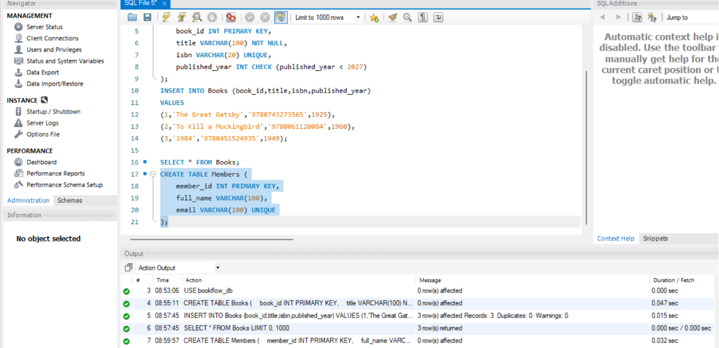
Step 5: Insert Records into Members Table
SQL Query
INSERT INTO Members VALUES
(101,'John Smith','john.smith@email.com'),
(102,'Emma Wilson','emma.wilson@email.com'),
(103,'Michael Brown','michael.brown@email.com');
SELECT * FROM Members;
OUTPUT:
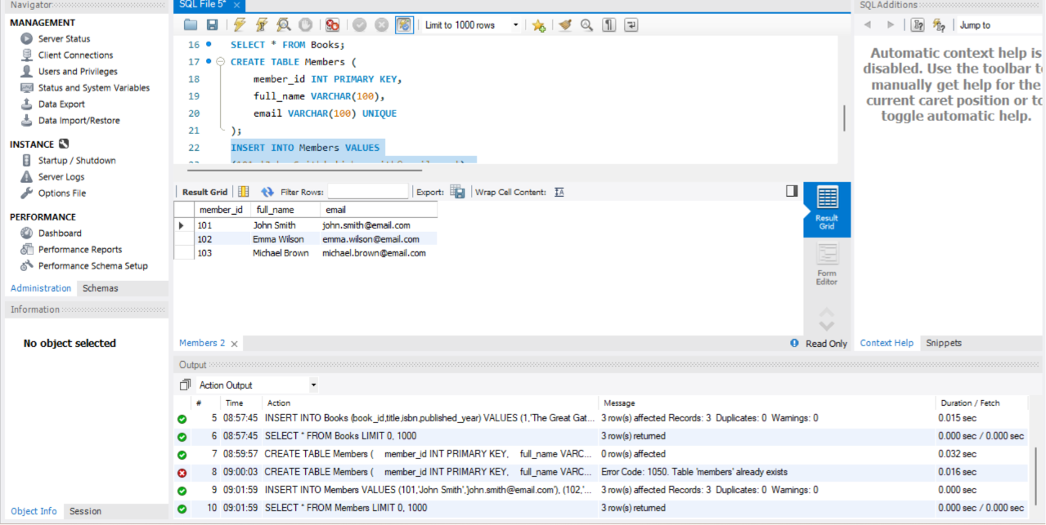

Step 6: Create Loans Table
SQL Query
CREATE TABLE Loans (
loan_id INT PRIMARY KEY,
member_id INT,
book_id INT,
loan_date DATE,
FOREIGN KEY(member_id) REFERENCES Members(member_id),
FOREIGN KEY(book_id) REFERENCES Books(book_id)
);

OUTPUT:

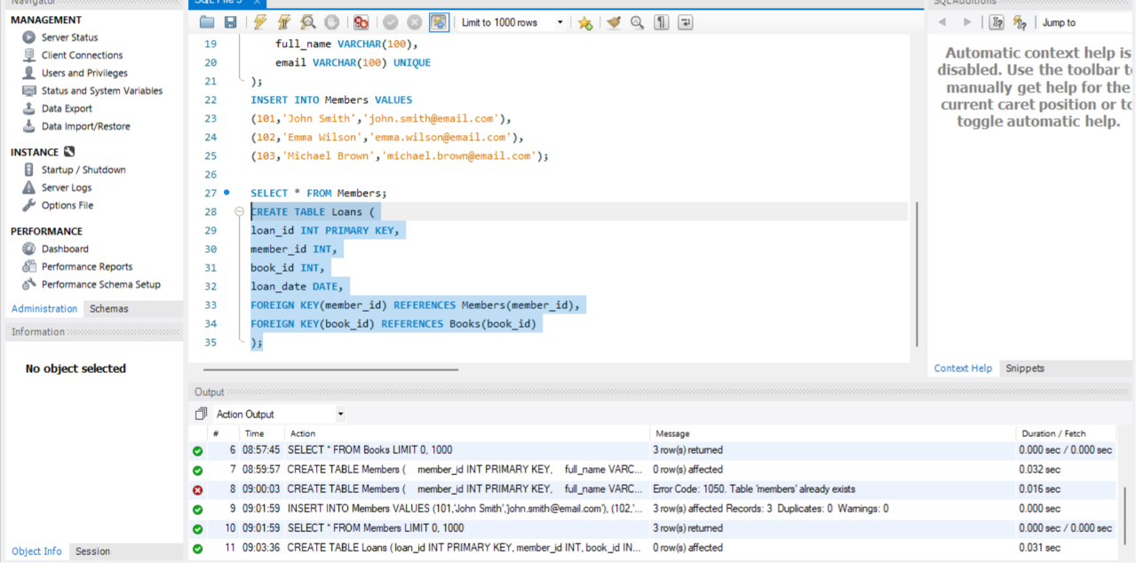

Step 7: Insert Records into Loans Table
SQL Query
INSERT INTO Loans VALUES
(1,101,1,'2025-01-05'),
(2,102,2,'2025-01-08'),
(3,103,3,'2025-01-10'),
(4,101,2,'2025-02-01'),
(5,102,1,'2025-02-05'),
(6,103,2,'2025-02-12'),
(7,101,3,'2025-03-01'),
(8,102,3,'2025-03-07'),
(9,103,1,'2025-03-15'),
(10,101,1,'2025-04-01');
SELECT * FROM Loans;
OUTPUT:

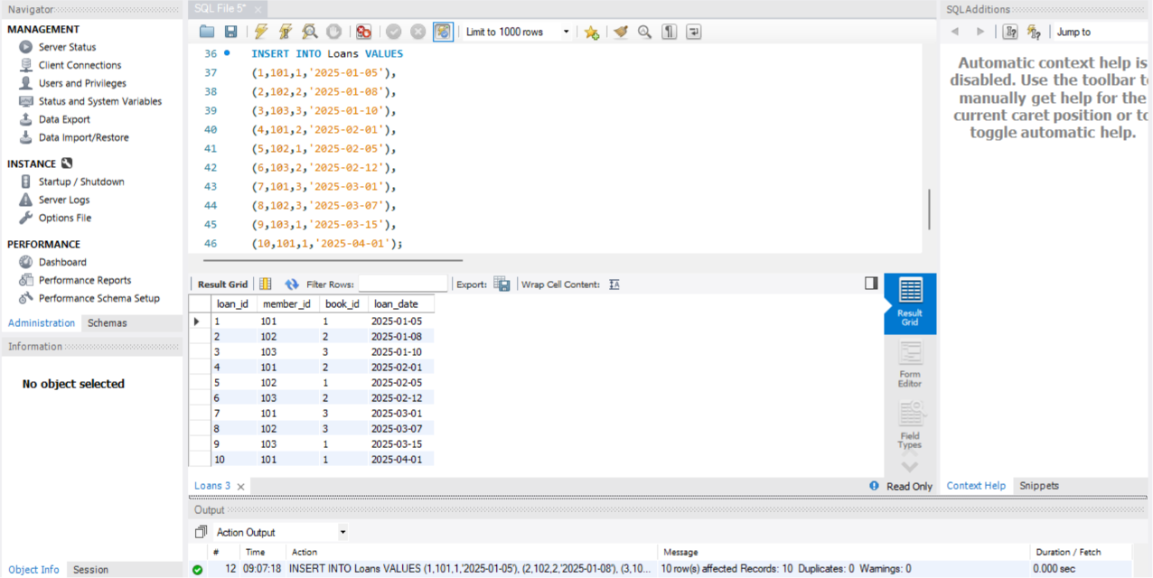
Step 8: INNER JOIN Query
SQL Query
SELECT m.full_name AS Member_Name,
b.title AS Book_Title
FROM Loans l
INNER JOIN Members m
ON l.member_id=m.member_id
INNER JOIN Books b
ON l.book_id=b.book_id;
OUTPUT:

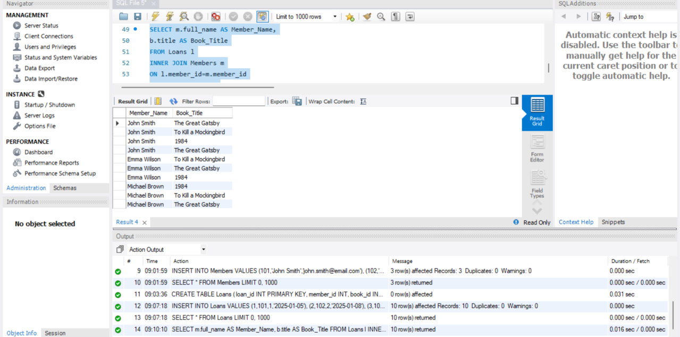

Step 9: GROUP BY Query
SQL Query
SELECT published_year,
COUNT(book_id) AS Total_Books
FROM Books
GROUP BY published_year
ORDER BY published_year;
OUTPUT:
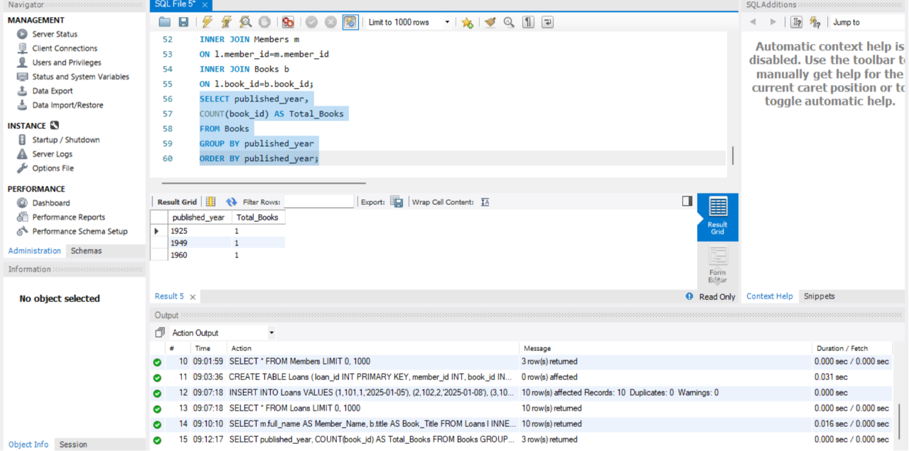

Step 10: Create Donation_History Table
SQL Query
CREATE TABLE Donation_History (
donation_id INT PRIMARY KEY,
book_id INT,
donor_name VARCHAR(100),
donation_date DATE,
FOREIGN KEY(book_id) REFERENCES Books(book_id)
);

OUTPUT:
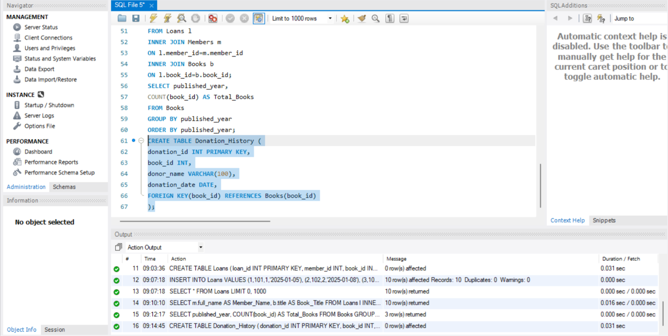
Step 11: Transaction
SQL Query
START TRANSACTION;

INSERT INTO Books
VALUES
(4,'Animal Farm','9780451526342',1945);

INSERT INTO Donation_History
VALUES
(1,4,'Raj Kumar',CURDATE());

COMMIT;

SELECT * FROM Books;
SELECT * FROM Donation_History;
OUTPUT:
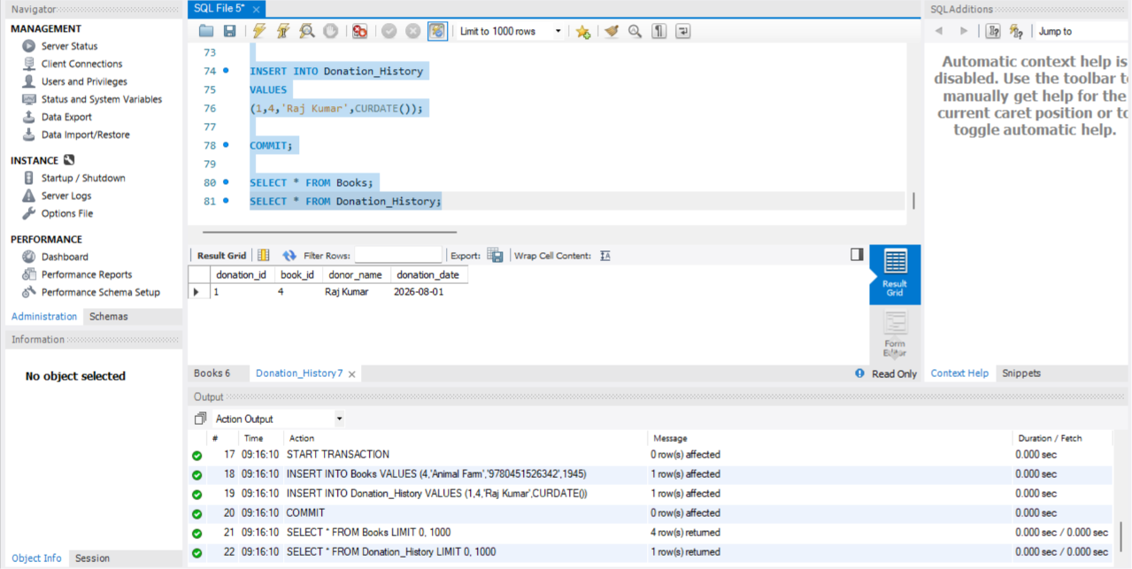

Step 12: Create Index
SQL Query
CREATE INDEX idx_books_isbn
ON Books(isbn);

SELECT * FROM Books
WHERE isbn='9780451524935';

OUTPUT:
